We Made History!

We Made History! A Shuttle Program Celebration DVD (contact D.Kimes for copy: email + land-mail address below )
- Shuttle Legacy (with background music and sound effects)
- Majestic Shuttle (some Shuttle history shots and a cool song in the background)
- We All Do What We Can Do (the song pulls at my heart strings having worked 37 years in the Apollo & Shuttle Programs)
- KSC Visitor Complex - The New Home of Space Shuttle Atlantis
- STS-135 Launch & Landing (The final flight. By the way - Atlantis carried my 1980 Olympic pin into orbit in 1992)

"Space Map" AKA The Space Center Electronic Map DVD (contact David Kimes for complimentary DVD copy)
* A progression of the physical layout - the history of Cape Canaveral and the Kennedy Space Center, covering 475 years.
---
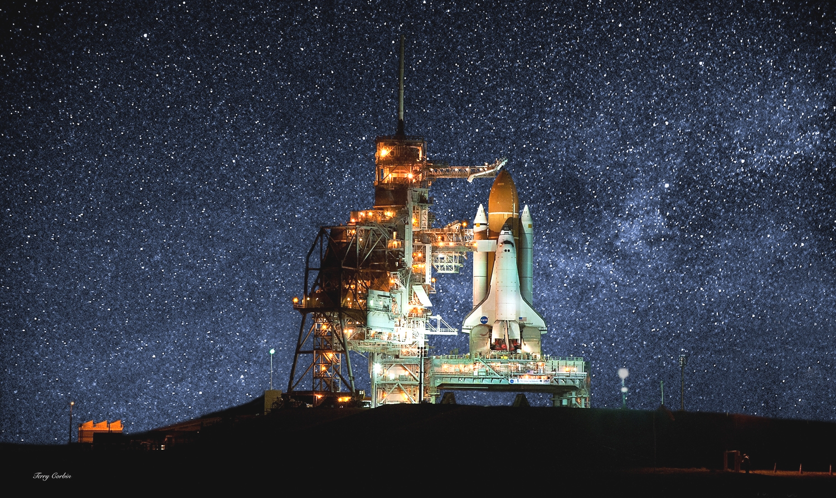
"Somewhere, something incredible
is waiting to be known."
-- Carl Sagan
---
"Sometimes I think we're alone in the universe,
and sometimes I think we're not.
In either case - the idea is staggering."
-- Arthur C. Clarke, Scientist/Author/Futurist
---
"I believe there are moments in history when challenges
occur of such a compelling nature, that to miss them
is to miss the whole meaning of such an epoch.
Space is such a challenge."
-- James A. Michener
---
Shuttle Astronaut:
“That's what you must do
if you want to go on your own journey to your dream.
Show courage. Do the difficult. Have faith.
As is true with those who travel into space,
you must be willing to go too far in order to discover
just how far you can really go.”
---
“The fourth landing of Columbia
is the historical equivalent of the driving of the golden spike,
which completed the first transcontinental railroad.
It marks our entrance into a new era.”
-- President Ronald Reagan, on the final test flight
of the Space Shuttle, STS-4, 4 July 1982
---
July 6th, 2000 - in front of Building 17 – Boeing, Huntington Beach:
Talking about the employees working in the space program:
"...it's not just a job, it's a destiny", Scott Horowitz, STS-101.
It was Scott Horowitz’s idea that the STS-101 presentation certificates to all employees included a small
triangle of duct tape flown on STS-101, having covered 4 million miles.
Astronaut Horowitz called it "Mach 25 duct tape".
For a copy of that certificate or the DVDs mentioned above: David Kimes, 5712 Conifer Drive, La Palma CA 90623
---
Space Shuttle Main Engines (SSME):
The SSME operates at greater temperature extremes than any mechanical system in common use today.
The liquid hydrogen fuel is -423 degrees Fahrenheit, the second-coldest liquid on Earth.
When the hydrogen is burned with liquid oxygen, the temperature in the engine's combustion chamber
reaches +6000 degrees Fahrenheit.
The maximum equivalent horsepower developed by the three SSMEs during launch
is more than 37 million horsepower.
The energy released by the SSMEs is equivalent to the output of 23 Hoover Dams.
(this does not include the two solid fuel booster rockets - SRBs)
During launch – a total of 77 million horsepower is in play.
As the Shuttle is clearing the launch tower, it is reaching 100 miles per hour straight up (of course).
8 and 1/2 minutes into the launch, it is traveling the speed to cover 80 football fields in one second.

---
The 2nd segment on the We Made History! DVD:
Tom Moser, was the Chief of Structural Design on the Space Shuttle Program for NASA between 1972 and 1982. Dennis Lohaus, who wrote and recorded the song, had worked at Kennedy Space Center on the Shuttle Program as an engineer for the past 31 years.
He wrote: “To my friends, family and team members that have experienced or been part of the Shuttle Program,
it is too bad that the Shuttle Program is coming to an end. After the first Shuttle flight someone from South Africa , who was in awe of the Shuttle, said he was amazed that the U.S. was not exploiting the great accomplishment by going around the world and talking about it. Perhaps it was thought the Shuttle would
speak for itself. It has! Now we are on the verge of grounding the greatest machine ever.
There is not a replacement, there is still a need and there is still nothing like it.
I hope you listen to this beautiful, heartfelt song by a longtime Shuttle Engineer down at the Cape.
It can also be found on the Internet: www.youtube.com/watch?v=EXFVaFV0FUo
---
Ultimate Space Shuttle Tribute: www.youtube.com/watch?v=YjpAHiyz8wc
STS-134 Ascent Imagery Highlights - www.youtube.com/watch?v=DO7ZBp4HXQA <the final Shuttle flight>
The Space Shuttle - Narrated by William Shatner with music from Batman (14 minutes):
www.youtube.com/watch?v=rlG7W0gkjjE&feature=related
Question: Baseball's Ted Williams flew in the same Korean War fighter plane as what future astronaut?
Answer: John Glenn
---
A 747 Pilot tells about flying the Shuttle Carrier Aircraft
This was circulated in email at work, from United Technologies corporate.
A quick "trip report" from the pilot of the 747 who flew the shuttle back to Florida after the Hubble repair flight.
A humorous and interesting inside look at what it's like to fly two aircraft at once:
...
(I have decided to adopt one of "Triple Nickel's" phrases : "That was too close for MY laundry!")
Well, it's been 48 hours since I landed the 747 with the shuttle Atlantis on top and I am still buzzing from the experience. I have to say that my whole mind, body and soul went into the professional mode just before engine start in Mississippi, and stayed there, where it all needed to be, until well after the flight...in fact, I am not sure if it is all back to normal as I type this email. The experience was surreal. Seeing that "thing" on top of an already overly huge aircraft boggles my mind. The whole mission from takeoff to engine shutdown was unlike anything I had ever done. It was like a dream... someone else's dream.
We took off from Columbus AFB on their 12,000 foot runway, of which I used 11,999 1/2 feet to get the wheels off the ground. We were at 3,500 feet left to go of the runway, throttles full power, nose wheels still hugging the ground, copilot calling out decision speeds, the weight of Atlantis now screaming through my fingers clinched tightly on the controls, tires heating up to their near maximum temperature from the speed and the weight, and not yet at rotation speed, the speed at which I would be pulling on the controls to get the nose to rise. I just could not wait, and I mean I COULD NOT WAIT, and started pulling early. If I had waited until rotation speed, we would not have rotated enough to get airborne by the end of the runway. So I pulled on the controls early and started our rotation to the takeoff attitude. The wheels finally lifted off as we passed over the stripe marking the end of the runway and my next hurdle (physically) was a line of trees 1,000 feet off the departure end of Runway 16. All I knew was we were flying and so I directed the gear to be retracted and the flaps to be moved from Flaps 20 to Flaps 10 as I pulled even harder on the controls. I must say, those trees were beginning to look a lot like those brushes in the drive through car washes so I pulled even harder yet! I think I saw a bird just fold its wings and fall out of a tree as if to say "Oh just take me". Okay, we cleared the trees, duh, but it was way too close for my laundry. As we started to actually climb, at only 100 feet per minute, I smelled something that reminded me of touring the Heineken Brewery in Europe ...I said "is that a skunk I smell?" and the veterans of shuttle carrying looked at me and smiled and said "Tires"! I said "TIRES??? OURS???" They smiled and shook their heads as if to call their Captain an amateur...okay, at that point I was. The tires were so hot you could smell them in the cockpit. My mind could not get over, from this point on, that this was something I had never experienced.
Where's your mom when you REALLY need her?
The flight down to Florida was an eternity. We cruised at 250 knots indicated, giving us about 315 knots of ground speed at 15,000' The miles didn't click by like I am use to them clicking by in a fighter jet at MACH .94. We were burning fuel at a rate of 40,000 pounds per hour or 130 pounds per mile, or one gallon every length of the fuselage. The vibration in the cockpit was mild, compared to down below and to the rear of the fuselage where it reminded me of that football game I had as a child where you turned it on and the players vibrated around the board. I felt like if I had plastic clips on my boots I could have vibrated to any spot in the fuselage I wanted to go without moving my legs...and the noise was deafening. The 747 flies with its nose 5 degrees up in the air to stay level, and when you bank, it feels like the shuttle is trying to say "hey, let's roll completely over on our back"...not a good thing I kept telling myself. SO I limited my bank angle to 15 degrees and even though a 180 degree course change took a full zip code to complete, it was the safe way to turn this monster.
Airliners and even a flight of two F-16s deviated from their flight plans to catch a glimpse of us along the way. We dodged what was in reality very few clouds and storms, despite what everyone thought, and arrived in Florida with 51,000 pounds of fuel too much to land with. We can't land heavier than 600,000 pounds total weight and so we had to do something with that fuel. I had an idea...let's fly low and slow and show this beast off to all the taxpayers in Florida lucky enough to be outside on that Tuesday afternoon. So at Ormond Beach we let down to 1,000 feet above the ground/water and flew just east of the beach out over the water. Then, once we reached the NASA airspace of the Kennedy Space Center , we cut over to the Banana/Indian Rivers and flew down the middle of them to show the people of Titusville , Port St.Johns and Melbourne just what a 747 with a shuttle on it looked like. We stayed at 1,000 feet and since we were dragging our flaps at "Flaps 5", our speed was down to around 190 to 210 knots. We could see traffic stopping in the middle of roads to take a look. We heard later that a Little League Baseball game stopped to look and everyone cheered as we became their 7th inning stretch. Oh say can you see...
After reaching Vero Beach , we turned north to follow the coast line back up to the Shuttle Landing Facility (SLF). There was not one person laying on the beach...they were all standing and waving! "What a sight" I thought...and figured they were thinking the same thing. All this time I was bugging the engineers, all three of them, to re-compute our fuel and tell me when it was time to land. They kept saying "Not yet Triple, keep showing this thing off" which was not a bad thing to be doing. However, all this time the thought that the landing, the muscling of this 600,000 pound beast, was getting closer and closer to my reality. I was pumped up! We got back to the SLF and were still 10,000 pounds too heavy to land so I said I was going to do a low approach over the SLF going the opposite direction of landing traffic that day. So at 300 feet, we flew down the runway, rocking our wings like a whale rolling on its side to say "hello" to the people looking on! One turn out of traffic and back to the runway to land...still 3,000 pounds over gross weight limit. But the engineers agreed that if the landing were smooth, there would be no problem. "Oh thanks guys, a little extra pressure is just what I needed!" So we landed at 603,000 pounds and very smoothly if I have to say so myself. The landing was so totally controlled and on speed, that it was fun. There were a few surprises that I dealt with, like the 747 falls like a rock with the orbiter on it if you pull the throttles off at the "normal" point in a landing and secondly, if you thought you could hold the nose off the ground after the mains touch down, think again...IT IS COMING DOWN!!! So I "flew it down" to the ground and saved what I have seen in videos of a nose slap after landing. Bob's video supports this! :8-)
Then I turned on my phone after coming to a full stop only to find 50 bazillion emails and phone messages from all of you who were so super to be watching and cheering us on! What a treat, I can't thank y'all enough. For those who watched, you wondered why we sat there so long. Well, the shuttle had very hazardous chemicals on board and we had to be "sniffed" to determine if any had leaked or were leaking. They checked for Monomethylhydrazine (N2H4 for Charlie Hudson) and nitrogen tetroxide (N2O4). Even though we were "clean", it took way too long for them to tow us in to the mate-demate area. Sorry for those who stuck it out and even waited until we exited the jet. I am sure I will wake up in the middle of the night here soon, screaming and standing straight up dripping wet with sweat from the realization of what had happened. It was a thrill of a lifetime. Again I want to thank everyone for your interest and support. It felt good to bring Atlantis home in one piece after she had worked so hard getting to the Hubble Space Telescope and back.
…
Go to www.intrepidmuseum.org/shuttle/home.aspx for a photo gallery of the Shuttles being ferried by 747s.
The ENTERPRISE was shuttled to NY City on Friday the 27th of April, 2012 – and by July was aboard the Carrier Intrepid – now the ‘Intrepid Sea, Air & Space Museum’.
---
From a friend in Washington, DC:
“Yesterday I went to the mall to watch the space shuttle as it was flown over DC on the back of a 747 to its final destination at the Smithsonian. I was somewhat disappointed being so far from the flyover but I think the disappointment was motivated more by the sadness of the space program's end and the difference from the spectacle and overwhelming power of a live launch.
As the astronaut advised a kid when asked how to be an astronaut, he said, “Learn Russian”. Sad. Really sad.
---
Before ending this Shuttle narrative, here is a little Apollo history.
< I was hired by Rockwell in February of 1968, 18 months before the landing on the moon during the Apollo 11 mission. >
---
The companies that have made Downey, California, the "Future Unlimited" home of the Apollo and Space Shuttle
what it was:
* First it was the E. M. Smith Company in the 1920s,
* then they changed the name to EMSCO (E.M. Smith Co.)
in the late 20's or early 30's
* and then Vultee Aircraft in the 30's or early 40's,
* North America Aviation in the early to mid 40's, with Dutch and the boys at the helm,
* North American Rockwell, Rockwell International, Boeing North American Inc..
---
With a story as well known as the opening of the Space Race, and one with few new revelations and insights, A Ball, A Dog, and A Monkey focuses primarily on stories from some of the people (primarily American) involved in that first year of the Space Age. Some of them are famous: Eisenhower, Werner von Braun, and James Van Allen - the Iowa physicist whose experiments were flown on Explorer 1. Others are more obscure, yet still interesting. For example, there’s the story of Bradford Whipple, an airman assigned to a listening post in West Germany who was one of the first to detect the signals from Sputnik after its launch. The following summer, while on leave in Brussels to attend the world’s fair there, he is recruited by a mysterious American—presumably an intelligence agent of some sort—to stand guard outside the Soviet pavilion there one night while a group steals the Sputnik model on display there, returning it a couple hours later after studying it.
---
First viewed earth rise from Apollo – Apollo 8 - www.youtube.com/embed/dE-vOscpiNc
---
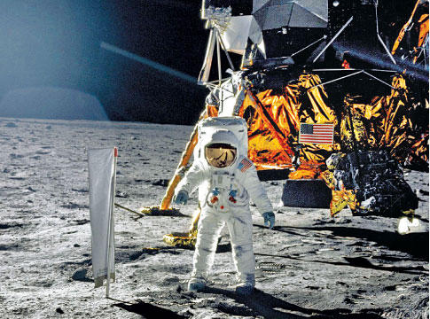
PHOTO: Camera Shy Neil Armstrong's reflection in Buzz Aldrin's visor is one of the few photos of Armstrong on the moon.
HERE MEN FROM THE PLANET EARTH
FIRST SET FOOT UPON THE MOON
JULY 1969 A.D.
WE CAME IN PEACE FOR ALL MANKIND
From the plaque on the Eagle, Apollo 11 mission
which landed on the moon, July 20, 1969.
---
Some trivia from the first Apollo mission that landed on the moon:
- In the audience of invited dignitaries to watch the launch of Apollo 11, July, 1969, was Charles Lindbergh –
imagine his thoughts?
Neil Armstrong once paid tribute to Lindbergh, saying: "He did it alone. We had a cast of a million."
- What part of the Wright Brothers made it to the moon? A piece of fabric and a piece of the propeller from the Wright Flyer
was taken on that Apollo 11 flight and left on the moon.
- Question: What was first eaten and the first liquid poured on the moon?
What follows is an article by Eric Metaxas:
“Forty years ago two human beings changed history by walking on the surface of the moon. But what happened before Buzz Aldrin and Neil Armstrong exited the Lunar Module is perhaps even more amazing, if only because so few people know about it.
I'm talking about the fact that Buzz Aldrin took communion on the surface of the moon.
Some months after his return, he wrote about it in Guideposts magazine.
And a few years ago I had the privilege of meeting him myself. I asked him about it and he confirmed the story to me, and I wrote about it in my book ‘Everything You Always Wanted to Know About God (But Were Afraid to Ask)’.
The background to the story is that Aldrin was an elder at his Presbyterian Church in Texas during this period in his life, and knowing that he would soon be doing something unprecedented in human history, he felt he should mark the occasion somehow, and he asked his minister to help him. And so the minister consecrated a communion wafer and a small vial of communion wine. And Buzz Aldrin took them with him out of the Earth's orbit and on to the surface of the moon.
He and Armstrong had only been on the lunar surface for a few minutes when Aldrin made the following public statement:
"This is the LM pilot. I'd like to take this opportunity to ask every person listening in, whoever and wherever they may be, to pause for a moment and contemplate the events of the past few hours and to give thanks in his or her own way."
He then ended radio communication and there, on the silent surface of the moon, 250,000 miles from home, he read a verse from the Gospel of John, and he took communion. Here is his own account of what happened:
"In the radio blackout, I opened the little plastic packages which contained the bread and the wine. I poured the wine into the chalice our church had given me. In the one-sixth gravity of the moon, the wine slowly curled and gracefully came up the side of the cup. Then I read the Scripture, 'I am the vine, you are the branches. Whosoever abides in me will bring forth much fruit. Apart from me you can do nothing.’
I had intended to read my communion passage back to earth, but at the last minute [they] had requested that I not do this. NASA was already embroiled in a legal battle with Madelyn Murray O'Hare, the celebrated opponent of religion, over the Apollo 8 crew reading from Genesis while orbiting the moon on Christmas eve. I reluctantly agreed.
I ate the tiny Host and swallowed the wine. I gave thanks for the intelligence and spirit that had brought two young pilots to the Sea of Tranquility. It was interesting for me to think: the very first liquid ever poured on the moon, and the very first food eaten there, were the communion elements.
And of course, it's interesting to think that some of the first words spoken on the moon were the words of Jesus Christ,
who made the Earth and the moon - and Who, in the immortal words of Dante, is Himself the "Love that moves the Sun and other stars."”
---
NASA Apollo 11 - 30th Anniversary: (with interesting facts and photos and astronaut comments, et cetera )
www.hq.nasa.gov/office/pao/History/ap11ann/introduction.htm
---
The average distance between Earth and Moon is approximately 30 times Earth's diameter.
If you could fly to the Moon at a constant speed of 1000 kilometers per hour (~600 mph),
which is the speed of a fast passenger jet, it would take sixteen days to get there.
Apollo astronauts reached the Moon in less than four days even though they coasted "uphill" almost the entire distance.
...
The average distance from the earth to the moon, the semi-major axis of its orbit, centre-to-centre distance
from the Earth to the Moon is 384,403 kilometers (238,857 miles).
...
The moon gets one inch further from the earth every year.
---
An anagram is a word or phrase made by rearranging the letters of another word or phrase.
It has been said, "All the life's wisdom can be found in anagrams. Anagrams never lie."
Here, from Armstrong’s quote as he stepped onto the moon:
"That's one small step for a man, one giant leap for mankind.”
The anagram: "A thin man ran; makes a large stride, left planet,
pins flag on moon! On to Mars!"
---
FYI / BTW:
NASA never built a rocket, never launched anything, never built a computer - they paid for all that, they supervised it,
but NASA never built anything. It was private industry; it was the private sector that did all that.
…
There's a pesky little detail that moon-landing conspiracy theorists fail to explain. One task of our manned lunar program
was to position a mirror on the moon that we could bounce laser signals off of so we could measure it's distance from the Earth.
We are still using that today. That is how they know that the moon is getting one inch further away from earth every year.
---

"OK, Houston, we have a problem!"
These chilling words, from Apollo 13 commander Jim Lovell, shook the world 30 years ago (04/10/2000).
"A crisis had begun,"
Longtime NASA mission flight director Gene Kranz writes in his book on the U.S. space program,
"Failure Is Not An Option"
---
•President Nixon made the longest-distance phone ever made from the Oval Office when he spoke with astronauts Neil Armstrong
and Buzz Aldrin as they walked on the moon - some 238,900 miles.
•First golf shot on the moon? It was with a 6 iron – Apollo 14 mission - by Alan Shepard.
---
Jim Albaugh, Boeing, 27 February, 2003 – in a letter to all Boeing employees:
“Helen Keller once said, (Remember Helen Keller? Born blind and deaf.)
"No pessimist ever discovered the secrets of the stars
...or sailed to an uncharted land
...or opened a new heaven to the human spirit."
It is the optimism and talent of Boeing people
(many of whom were former Rockwell people who designed and built the Apollo & Shuttle)
that permit us to do the hard stuff
and our customers count on us to do it better than anyone.”
---
And finally, this Shuttle Christmas Poem - written and passed along by Terri:
TWAS THE SHUTTLE’S LAST CHRISTMAS AND OUR SPIRITS WERE LOW,
FOR THE PROGRAM WAS ENDING AND SOON WE’D ALL GO.
WE’D PROCESSED THE SHUTTLES WITH INFINITE CARE
AND FOLLOWED EACH MISSION AS IF WE WERE THERE.
WE MADE EVERY EFFORT TO ACHIEVE ALL OUR GOALS;
WE OFFERED OUR TALENTS, OUR HEARTS AND OUR SOULS.
OUR WORK WAS MUCH MORE THAN A MEAGER CAREER;
‘TWAS AN HONOR AND PRIVILEGE BEYOND ALL COMPARE.
AS THIS MARVEL OF SCIENCE WAS APPLAUDED WORLDWIDE,
WE LOOKED ON EACH SHUTTLE WITH UNFETTERED PRIDE:
COLUMBIA, CHALLENGER, DISCOVERY, AND THEN
ATLANTIS, ENDEAVOUR ALL FERRIED BRAVE MEN
AND WOMEN TO REALMS PAST THE CONFINES OF EARTH,
UNCOVERING KNOWLEDGE OF INFINITE WORTH.
WE REJOICED WITH EACH MISSION’S SUCCESS, AND WE GRIEVED
FOR THE LOSSES TOO PAINFUL FOR US TO CONCEIVE.
AND OVER THE YEARS, SOMETHING WONDROUS TOOK PLACE:
WE BECAME KINDRED SPIRITS, UNITED BY SPACE.
AND SO, AS WE PART, I WILL BEAR A GREAT LOSS,
AND HOPE IN THE FUTURE OUR PATHS AGAIN CROSS.
BUT UNTIL THEN, MY FRIEND, THIS WISH I CONFIDE:
HAPPY CHRISTMAS TO ALL – WE HAD A GREAT RIDE.
---
Consider joining the Aerospace Legacy Foundation – 12214 Lakewood Blvd., Downey, CA 90242
Go to www.aerospacelegacyfoundation.com/ for more interesting history and photos.
The Queen of England, among many other dignitaries, visited Downey in California during the rise
of American aerospace.
---
The enclosed was assembled, gathered and preserved during my 37 years in aerospace. I was a fortunate part of that great ride. Sincerely, David Kimes – dwkimes@earthlink.net

